Kindly supported by the North West Regional Development Group

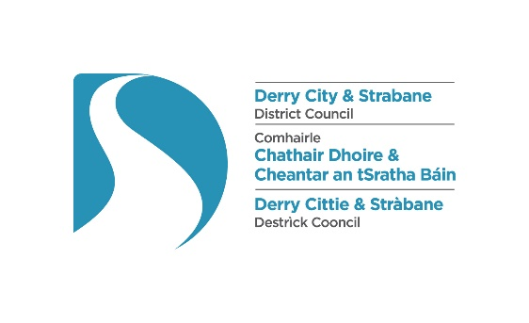

2022 North West Annual Future of Energy Conference and Exhibition

Date: Thursday 17 November
Time: 9.30am – 4.30pm
Location: Everglades Hotel, Prehen Road, Derry BT47 2NH

This full day conference is jointly hosted by the Chambers of Commerce in Londonderry and Letterkenny, kindly supported by the North West Regional Development Group, and will focus on the opportunities for investment, growth, innovation and job creation and also address the challenges to businesses of rising energy costs.

This event aims to
• Encourage cross border collaboration in the energy sector to the benefit of the whole North West city region
• Provide a platform for knowledge transfer and sharing to support economic growth of the North West region
• Support business growth and innovation in the energy sector
• Support NW businesses to meet sustainability goals in the move to net zero

Programme:

9.30am Registration, networking/ view display stands
10.00am Welcome on behalf of Londonderry and Letterkenny Chambers, Vice President Selina Horshi and President Kristine Reynolds

Jamie Delargy, MC, introduces the main sponsor TBC

10.05am Main Sponsor Address
10.15am Opening plenary

10.30am
Session 1
The Green Economy: Challenges to meet Carbon Reduction targets and the opportunities for Growth and Investment

Panel discussion with Chair

Key topic – Energy Efficiency
• Decarbonised Supply chain challenges and opportunities within the green economy for existing businesses - reducing carbon footprint.
• Significant need for retrofitting and relevant skills & services,
• Expertise in energy efficiency measures and implementing a circular economy
• The Essentials of an Enterprise, Social and Corporate Governance Framework
•Demand for relevant professional services, private investment required to meet renewable energy targets

Panel to include:
- Dr Patrick Keatley, Ulster University (Chair)
- Brett Ross, RiverRidge
- Christy Lynch, Efficient Renewables
- Donegal County Council TBC
- Alison McFadden, Continu
- Richard Rogers, Department for the Economy

11.15am Coffee Break

11.30am
Session 2
The Rising Cost of Energy: Protecting your Business
Key topic: Managing Energy Costs – alternatives

Case studies:
- Sam Alexander, Powerhouse Generation - Power purchase agreements, direct supply, futureproofing and advice oin how to interact with suppliers
- Brian O’Neill, Schneider Electric - Microgrids – Local community generation and storage

12.30pm Lunch break, networking/ visit exhibition stands

2.00pm
Session 3
Renewables: The road to Carbon Neutrality

Panel discussion with Chair

Key topics:
- Utilisation of the north-west’s onshore wind resources and offshore wind potential
- Grid Modernisation and grid connections
- Emerging sectors such as green hydrogen.
- energy from waste/circular economy (Biomethane, Biogas, methanol etc )

Panel to include:
- Jamie Delargy, Chair
- Ciaran Devine, Evermore
- Julie Parkinson, Sinbad Marine Services
- TBC, ANO, Enterprise Ireland

3.00pm
Session 4
Decarbonising our buildings and how we Transport
Case studies:

- Ian Campbell, Translink- EVs, EV infrastructure and charge network, solutions for public transport and hydrogen fuel cells
- Robert Clements, NIHE - Technology solutions for social housing

4.00pm Closing plenary

4.15pm Tea break and networking /visit display booths

4.30pm Event close

Conference fees:
- Londonderry and Letterkenny Chamber members FOC
- Non-members £30 + VAT

